Summary of Testing Approach

Alignment with Requirements
When I started the Contact Service back in Module 3, I honestly didn't know what I was doing. I just wrote tests that I thought would pass. But by the time I got to the Task Service in Module 4 and the Appointment Service in Module 5, I figured out a better approach. I started going through each requirement line by line and asking myself "how would I test this?"
For the Appointment Service, the requirements were pretty clear. The appointment ID had to be unique, not null, no longer than 10 characters, and not updatable. So I wrote tests for each of those. For example, in my AppointmentTest.java I have:
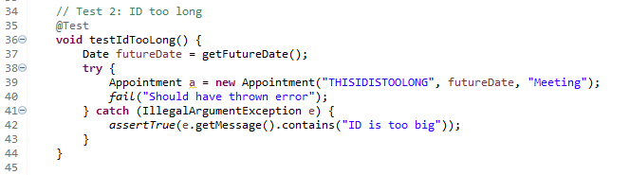
This test makes sure that if someone tries to create an ID longer than 10 characters, it throws the right error. I did the same thing for null IDs, past dates, descriptions that are too long, all of it. Every requirement has at least one test that checks it works right, and another test that checks it fails right. For the appointment date requirement, I had to learn how to work with dates in Java. The requirement said the date can't be in the past and can't be null. So I wrote: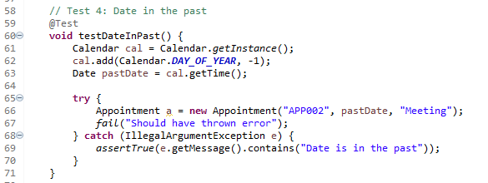

Test Effectiveness and Coverage
One thing that helped me feel confident about my tests was using Eclipse's coverage tool. For the Task Service, I got 82.3% overall coverage, with Task.java itself hitting 100%. That meant every line of validation code in my Task class was being tested. For the Appointment Service, all 20 tests passed, which felt pretty good. Assertions like assertEquals, assertTrue, and assertFalse are the main way we verify things in JUnit 5. I used all of these in my tests.
Writing Technically Sound Code
To make sure my code was technically sound, I focused on a few things. First, I made sure validation happened as early as possible. In my Appointment class constructor, I check for nulls and length limits right away: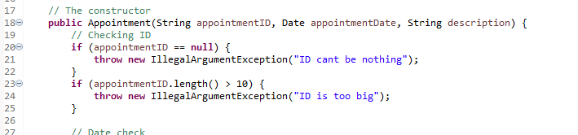
I also made sure my error messages were helpful. Instead of just throwing generic exceptions, I included messages that tell you what actually went wrong. That way when a test fails, you know why.

Writing Efficient Code
For efficiency, I used @BeforeEach to set up fresh service objects before each test. In AppointmentServiceTest.java I have:
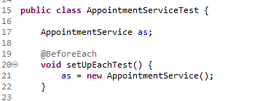
This way each test starts with a clean service, and tests don't interfere with each other. I also kept my test methods focused on testing one thing at a time. Each test has a clear purpose, like testing duplicate IDs or testing null descriptions. That makes them easier to debug when something fails.

Reflection on Testing Techniques

Techniques I Used
Looking back, I used several testing techniques without even realizing it at first. Unit testing was the main one. Each of my test classes focuses on one class only, like AppointmentTest only tests Appointment, not AppointmentService.
I also used boundary value analysis a lot. For the appointment description, the limit is 50 characters. So I tested with 50 characters (should work) and 51 characters (should fail). Same for IDs and names across all three services.
Negative testing was another big one. I spent almost as much time testing what should fail as testing what should work. Trying to add duplicate appointments, trying to delete appointments that don't exist, trying to update with bad data. Garcia (2017) talks about assertThrows for exactly this kind of thing, "to verify if a given exception is raised in a piece of code" (p. 16).

Techniques I Didn't Use
The textbook mentions several techniques I didn't use. Tagging and filtering with @Tag would let me categorize tests and run only certain groups. Garcia (2017) explains that "tags can later be used to filter test discovery and execution" (p. 23). For bigger projects, this would be useful to separate fast unit tests from slower integration tests, but for my 20-30 tests total, it wasn't needed.
Nested tests with @Nested would let me organize related tests together. The textbook shows an example testing a stack, with nested classes for different states (p. 40-44). I could have used this for testing different appointment states, but my tests were simple enough that flat structure worked fine.

Practical Uses of These Techniques
The techniques I used are great for small to medium projects where you're testing individual classes and their interactions. Unit testing and boundary analysis catch most bugs early, and negative testing ensures your error handling works. For larger enterprise projects, tagging and filtering become essential. If you have thousands of tests, you don't want to run them all every time.

Mindset and Approach

Employing Caution
When I started this project, I thought testing was just about proving my code worked. But I learned pretty quickly that the real value is in proving it doesn't break when things go wrong. I had to be cautious and think like someone trying to break my code, not like someone trying to make it work. For example, in the Appointment Service, I thought about what would happen if someone passed in a null date. Or a date in the past. Or a really long description. Each of those seemed like things a real user might accidentally do, and I wanted my code to handle it gracefully.

Limiting Bias
It's hard to test your own code objectively. When I write something, I naturally think it's correct. I had to force myself to look for problems instead of assuming everything was fine. One way I limited bias was by writing tests first, or at least thinking about tests while writing the code. Another thing was reading the requirements carefully and making sure I wasn't adding my own assumptions.

Discipline and Quality
This project really showed me why being disciplined about testing matters. It would have been easy to just write the code and call it done, but that's how bugs slip through. Taking the time to write thorough tests, even for the boring edge cases, is what makes software reliable. I also learned that good error messages matter. In my Appointment class, I used messages like "ID cant be nothing" and "Date is in the past." These make debugging easier and help anyone using my code understand what they did wrong.

Conclusion
Working through the Contact, Task, and Appointment Services taught me a lot about testing. I started with basically no clue what I was doing, and by the end I had 20 passing tests and coverage over 80%. More importantly, I learned to think like a tester, looking for ways things could break instead of just assuming they work. The textbook was helpful for understanding the theory behind what I was doing. Garcia's explanations of assertions, test lifecycle, and different testing techniques gave me a vocabulary for what I was learning by doing. I can see now that testing isn't just an add-on to development, it's part of the whole process of writing good software.

Reference:
Garcia, B. (2017). JUnit 5 standard tests. In Mastering Software Testing with JUnit 5. Packt Publishing.

